Project Setup & Angular Fundamentals,
1. What is Angular? Core Architecture and Features.
-> Angular is a frontend framework made by Google. It helps us build web apps that run in the browser — especially
Single Page Applications (SPAs).
This means when you click around in the app, it doesn’t reload the whole page. It only updates the parts that
change.
-> Angular uses(6 building blocks):
-> Components are the building blocks of the UI in Angular.
-> In Angular, everything visible on the screen is part of a component. I divide the UI into small parts like
header, footer, sidebar, product list, Cart, Login, signup etc., and create separate components for each.
-> Components help me manage HTML, CSS, and logic in one place, making the code easier to reuse and test.
-> Modules help organize related components, services, and other code together.
-> We use modules to break a large application into small, manageable sections. Each module can contain its
own components, routing, and services.
-> This helps in lazy loading, reusability, and better team collaboration.
-> EX: Feature Module(Home, Product, Cart, User)
CoreModule(used for singleton services and app-wide feature that should load only Once, EX:
AuthService, Logger Service, Interceptor), No component Usually and Imported only in AppModule.
SharedModule(Button, Spinner, HeaderCOmponents.)
-> Services are used for writing logic that is not related to UI, like fetching data or business rules.
-> We use services for tasks like calling APIs, sharing data between components, or handling business logic.
-> Services are injected using Angular's Dependency Injection, which helps keep components lightweight and
testable.
-> A UserService that handles login, signup, and user profile fetching, Spinner service, Error Handling.
-> Routing is used to navigate between different views or pages in a single-page Angular app.
-> We define different routes in app-routing.module.ts for navigating between pages like /login, /product/cart.
-> Routing allows us to load components dynamically based on the URL without reloading the page.
-> Ex: If user opens /cart or /productDetail, Angular loads CartComponent without refreshing the full page.
-> RxJS is a library for reactive programming using Observables.
-> We use RxJS for handling asynchronous data like HTTP responses, user events, and timers..
-> It helps me manage data streams and handle operations like debounce, retry, filter, map etc., in a clean and
powerful way.
-> EX: In a search bar, I use debounceTime() to avoid firing API calls on every keystroke, and only after user
stops typing.
-> TypeScript is a superset of JavaScript with static typing and object-oriented features.
-> I use TypeScript in Angular for writing clean, maintainable code. It gives me type safety, helpful
autocompletion, interfaces, classes, and access modifiers..
-> It catches errors during development and makes large projects easier to manage.
-> EX: I create interfaces like User, Course, etc., so that I know exactly what structure my data will have.
2. How to Set Up an Angular Project (Using Angular CLI)
-> Angular CLI is a tool that helps you create and manage Angular projects using commands in the terminal.
ng new <project-name> | Create new Angular proj & asks for routing & css/scss
ng generate component <name> | ng g c <name> | Creates a new component & Adds the new component to the right module automatically.
ng generate service <name> | ng g s <name> | Creates service-name.service.ts and .spec.ts & adds @Injectable() decorator
ng generate module <name> | ng g m <name> | Creates name.module.ts, Adds @NgModule with empty declarations, imports
ng serve | Compile and start dev server on localhost & auto reloads
ng build | ng build --prod | Build the app for deployment,  With --prod: minifies, removes debug info, tree-shakes unused code
3. Angular Project Folder and Important Files
Node_modules | - Folder storing all project dependencies to run, build ad test the app and gets created when  you run: npm install.  - Controlled via package.json, So team gets same version  - We never commit this, instead we commit package.json & package-lock.json file
package.json | - Lists your app’s dependencies and scripts (npm run <script-name>) to build/test it.  - You can add or remove libraries here | Can commit thss file
Package-lock.json | - It is an auto-generated file that records the exact versions of every package and its  dependencies installed in your project.  -Ex: "rxjs": "^7.5.0" in package.json, here I and other teammate may get different version  but if in package lock file it is mentioned as "rxjs": {"version": "7.5.1",} then this version  only gets install for all of us.  - while npm-run , It runs through lock file first and then runs package file for top-level  dependency  -We Can commit thss file  NOTE:  -If package-lock exists, npm install uses it first and install exact versions listed in lock file.  -If package-lock doesn’t exists, npm install isses package.json first and installs latest allowed versions and then it created a new package-lock.json
Angular.json | -angular.json is the file that tells Angular CLI how to handle my app — how to build it, where to find main files like main.ts, where to keep compiled files, how to create dist folder, how to serve, what global styles to include, what environments to use, and even how many apps or libraries my workspace has.  - We use this file: to Add global CSS file, Change build options like file replacements for different environments, Customize output paths for CI/CD pipelines, Control multiple apps/libraries in monorepos",  EX: ng serve --configuration=production  ng serve --configuration=staging
tsconfig.json | - It defines TS settings for the app (like target, module) and it can be extended by other tesconfig files  EX: "target": "ES2022",  "module": "ES2022"  Here, it tells to angular cli that convert my TS code into JS code that matches ES2022 standard.
tsconfig.app.json | - TS config used specifically during build/serve for the main app (not tests).  - It extends tsconfig.json and limits compilation to only app-related files (.ts, .html).  - here we define what to include and exclude and we include only .ts files  -- we mention the compiler type also which is ’node’ here
tsconfig.spec.json | - TS config used only for running unit tests (ng test).  - here we define what to include and exclude and we include spec and .ts files  - we mention the compiler type also which is ‘jasmine’ here
polyfills.ts | - Ensures older browsers can run the moedern javascript app by filling in missing JS features.  EX: import 'web-animations-js';
main.ts | - Angular app entry point — It’s reponsibile for bootstraping the root module.(App modul)  - we make changes for cutom bootstaraping logic(based on FLags)
index.html | - It serves as a single entry point for whole application.  - It contains <app-root></app-root> this a placeholder where angular renders the SPA app
app.module.ts | - The root module of the app.  - A module in Angular is like a container that groups related pieces together — components,  directives, pipes, and services — so that they work together.  - It’s the starting point where Angular knows what parts of your app exist and how to start  running it.  - Bootstraps the root component of the application  - Import other Angular or third-party modules like HttpClientModule, FormsModule, etc.
app.component.ts | - The root component of the app.  - This is where I place header/footer/layout logic.  - use this to manage page loaders, global toasts, and scroll-to-top behavior.  - .html file will have ‘<router-outlet></router-outlet>  -> is a directive provided by the Angular Router module. It acts as a viewport within the  application layout where routed components are rendered dynamically. This allows  Angular applications to have multiple views or pages without the need for full-page  reloads.
app-routing.module.ts | - Handles SPA routing for the entire app.  - I set up lazy loading, canActivate guards, and route-level metadata like breadcrumbs or  permissions.
4. IMP - How Angular Bootstraps and Loads the UI:
Q & A:
What happens after you do ‘ng serve’:
Ans: • Angular CLI compiles your app in memory using Webpack (no files in dist/).
• It starts a development server at http://localhost:4200.
• It serves index.html, which has <app-root> and a reference to main.js.
• The browser loads main.js (compiled from main.ts).
• main.ts bootstraps AppModule.
• AppModule bootstraps AppComponent.
• Angular replaces <app-root> in index.html with the HTML from app.component.html.
• Inside AppComponent, <router-outlet> shows the routed component based on the URL.

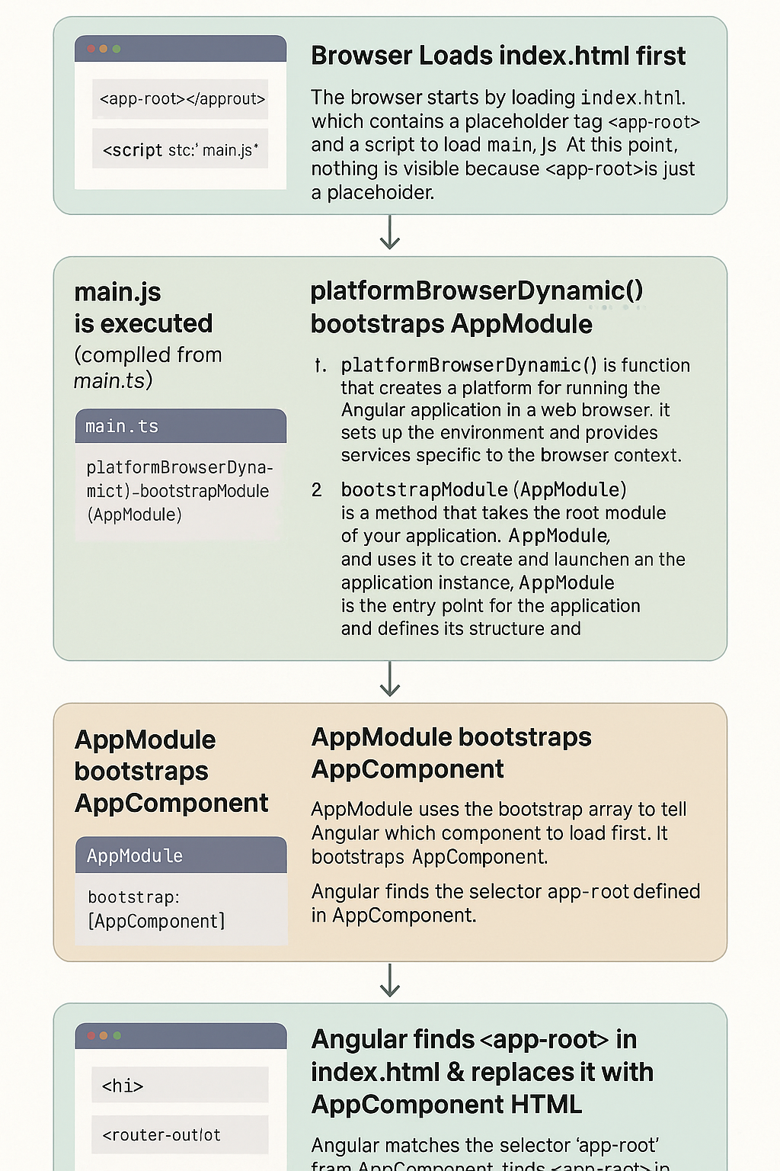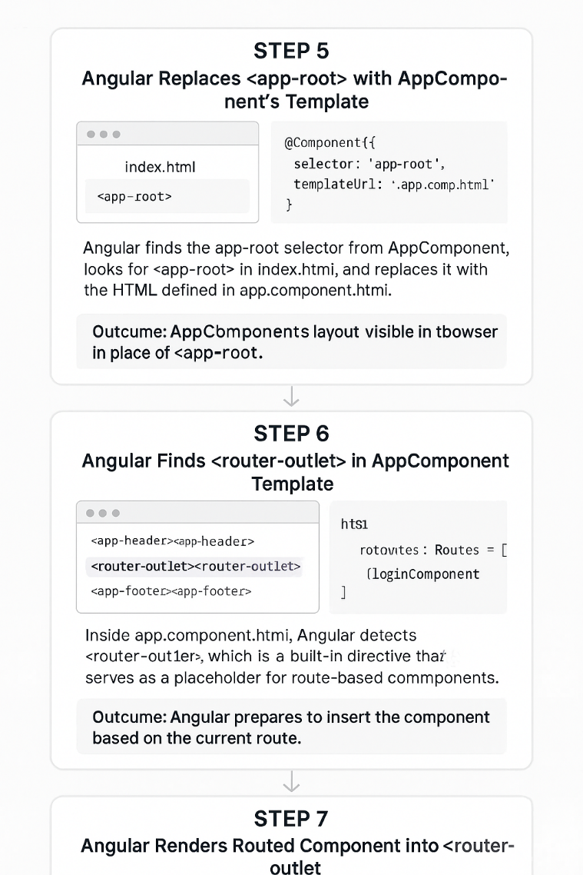
5. Angular Component Structure & Metadata:
What is a Component?
-> Building block of Angular app (controls part of UI). And Contains: .ts (logic), .html (template), .css (style).
What is @Component Decorator and Metadata Fields?
-> Used to define a component. And Has metadata: selector, template/templateUrl, styles/styleUrls.
@Component({
selector: 'app-home', // Custom HTML Tag(e.g. <app-home>)
templateUrl: './home.component.html', // Path to HTML template file
template: '<h1>{{ message }}</h1>', //Inline HTML (used for small components)
styleUrls: ['./home.component.css'], // path to CSS/SCSS file's
styles : ['h1 { color: red; }'] //nline CSS (less common)
})
export class HomeComponent {
title = 'angular-test-proj'; }
TypeScript
1. Interfaces:
- An interface defines the shape of an object (structure, properties, types).
- In Angular, Used to define data models (e.g., user, product, API response) so we know what to expect
fromservices or backend calls.
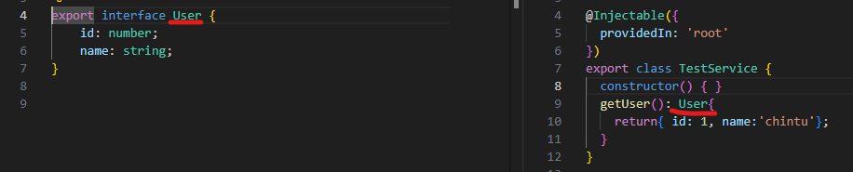
2. Clases:
- Classes are blueprints for creating objects and contain properties, methods, and constructors.
- Every component, service, and directive is a class.
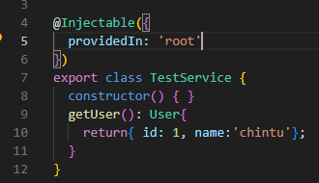
3. Access Modifiers:
- Control visibility of class members.(properties, and methods), means control where a class member (property or
method) can be accessed from
- Three main access modifiers (public, private, protected)
- public – accessible from anywhere
- private – accessible only inside the class.
- protected – accessible within the class and subclasses, but not outside.
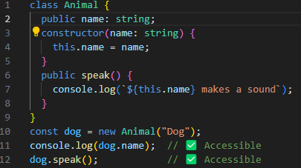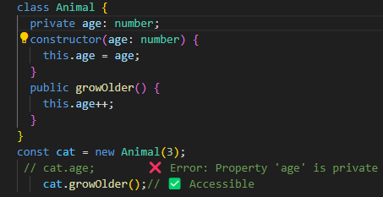
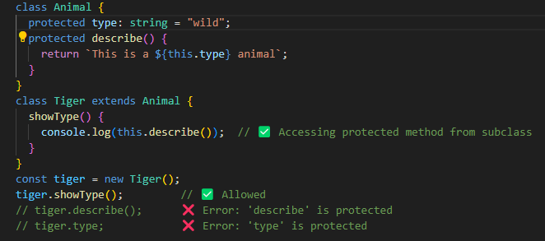
Angular exaple:
public:
- In a component, we write public title = 'Hello'; so that it can be used in the HTML template like {{ title }}.
- By default, everything in Angular is public if you don’t mention anything.
private:
- In a service, we store the login token as private token = '' so that other components can't access it directly.
- We give them access using a public getToken() method. This protects the internal logic.
protected:
- If we have a base component with protected logger, any child component that extends it can use that logger.
But outside components can’t access it.
4. Type Annotations (: string, : number, etc.)
- Tell TypeScript what type a variable or function should be. Prevents bugs, helps with code suggestions, and
improves readability. EX: let price: number = 500;, let title: string = 'Angular Book';
5. Union & Optional Types (|, ?)
- Allow variables to have more than one type or be optional.
- Useful when API returns different data types or optional fields. 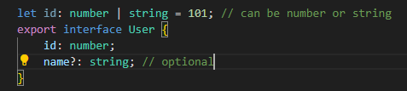
6. Generics
- Generics are like placeholders for types. They make your code reusable, type-safe, and flexible.
- Instead of fixing the data type, we use a variable type like <T> and pass the actual type when we use it.
Generic Methods:
- Here, <T>: We're telling TypeScript this function works with a generic type T, and will tell you the type when used.
value: T - input is of type T and T - return value is also type T
Generic Interface:
7. Decorators
- A decorator is a special function that adds extra behavior or metadata to a class, method, property, or parameter.
- It’s written using the @ symbol.
- we can also create custom decorator ex- to unsubscribe to avoid memory leak.
EX: we have
@Component -> Tells Angular: “This class is a component. Here's its selector and template.”
@Injectable -> Marks the service as injectable so Angular can provide it using dependency injection.
@Input() – lets the parent component pass data to the child.
@Output() – allows the child to emit events to the parent.
7. Modules: import / export:
- Modules in TypeScript are files.
- Each file can export code (classes, functions, variables, etc.), and other files can import and use that code.
- Uses: Organize code into separate files, Reuse code easily, Improve readability and maintainability,
EX: for services, SharesModule, Helper classes, components
2. Modules and Component Architecture
1. What is an Angular Module and Why It’s Important
- Every Angular app starts with one main module: AppModule
- Modules help organize related components, services, and other code together.
- We use modules to break a large application into small, manageable sections. Each module can contain its
own components, routing, and services.
- This helps in lazy loading, reusability, and better team collaboration.
- Each module is a class annotated with the @NgModule decorator.
- Module file has main 5 meta properties: declarations, Imports, Exports, providers and Bootstrap as mentioned
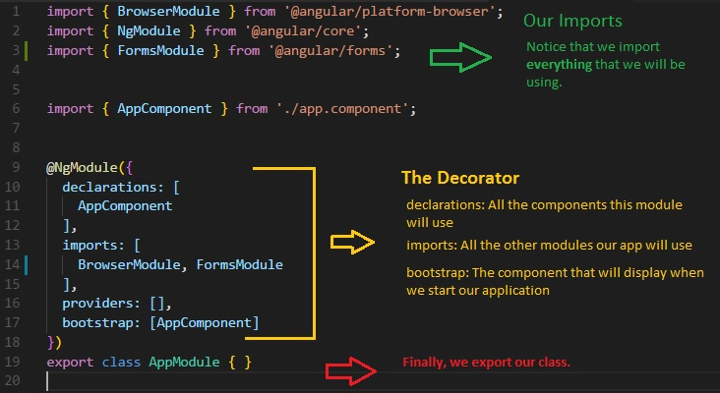
Exports: [] - declare component that we want to use outside.
Providers[] – services for the module
NOTE: - A component can be declared in only one module.
- To use a component in multiple modules:
- Declare it in SharedModule, Export it from SharedModule, Import SharedModule wherever you
want to use it
2. Different Types of Angular Modules & When to Use Each:
EX:
- AppModule : Root Module, bootstrap app , it’s a main entry point
- Feature Module: it encapsulate a specific feature Ex (Home, Product, Cart, User)
- CoreModule(used for singleton services and app-wide feature that should load only Once in i.e. AppModule
EX: AuthService, Logger/user Service, Interceptor), No component Usually and Imported only in AppModule.
- SharedModule(Button, Spinner, HeaderCOmponents.)
Best Practices:
- Use SharedModule for reusable UI stuff, Use CoreModule for singleton services (import only in AppModule)
And Lazy load large FeatureModules
Pitfalls:
- Don’t provide services in SharedModule → Multiple instances!
- Never import CoreModule in more than 1 place → Breaks singleton pattern.
3. Lazy Loading Modules (Bonus: Routing Best Practice):
- Lazy loading means loading a module only when it is needed, rather than loading it at the application's startup.
- This is mainly done through Angular’s Router. Instead of importing a module directly in AppModule, you
configure a route to load the module only when the user navigates to a specific path.
- Benefits:
- Performance --> Only necessary code is loaded upfront, reducing the initial load time.
- Reduced Bundle Size --> Keeps the main bundle small — rest is loaded as needed.
- Improved User Experience --> Faster startup, especially for large enterprise apps.
- Better Code Splitting --> Angular CLI splits the lazy-loaded modules into separate chunks (via Webpack).
- Creating a shared Module and Lazy Loaded Module and understand eager VS Lazy Loading Module
1. ng new module-comparison-demo
select Y for angular routing
2. cd module-comparison-demo
3. ng g module shared
4. ng g c shared/header created a heade component inside shared module
5. Used <app-header> in app.component.html to show shared header
6. ng g module admin --route admin --module app.module
select Y for angular routing it adds admin.module.ts and admint-rputig.module.ts and also add admin
Module as load children in app-routing.module.ts
const routes: Routes = [{ path: 'admin', loadChildren: () => import('./admin/admin.module').then(m =>
m.AdminModule) }];
7. Added this in app.component.html:
<app-header></app-header>
<a routerLink="/">Home</a>
<a routerLink="/admin">Admin</a>
<router-outlet></router-outlet>
✅ Final Behavior
On app load:
- AppModule, SharedModule, and HomeComponent load eagerly
Clicking "Admin":
- Loads AdminModule lazily
- You’ll see admin-admin-module.js in DevTools → Network → JS
2. Templates, Data Binding, and Directives
1. Templates in Angular: (.html file)
- Templates in Angular define how your UI is structured, using HTML + Angular syntax to display data, bind
properties, and attach logic.
- BP: Move complex logic into the component class.
- PF: Keep template readable; break large templates into child components.
2. Data Binding in Angular (4 Types)
- Data binding in Angular is a mechanism that synchronizes data between the component's logic (model) and its
template (view) Using 4 Types: Interpolation, Property Binding, Event Binding, Two-way Data Binding.
1. Interpolation ( {{ }} ) (one Way, compo template):
- To bind component data to the template view — especially useful for displaying strings or numeric values
directly.
It evaluates the expression ‘product.name’ from the component .ts and inject the value as a string in HTML
BP: Keep it for strings ans numbers O/P only.
Don’t use ot for complex expression {{ calculateTax(product.price) * 1.18 }}, use getter Or you can have this
complex calculation in .ts and assign into an variable then show in template
Calling method inside {{ }} triggers them on every change detection cycle — causes performance issues
2. Property ( [ ] ) (one Way, compo view):
- Property binding is used to bind a DOM element property to a component property in Angular using square[ ].
- Angular binds to DOM properties, not HTML attributes. So always use square brackets for binding DOM
properties and if you want to bind HTML Attributes like aria-lable, tabindex, use [attr.aria-label]
EX: HTML Attributes below for which use [attr.*]:
aria-label, aria-hidden, aria-expanded, role, tabindex,
NOTE: It’s difficult to remember all HTML Attributes and differentiate whether they are also DOM property
So, If a binding doesn't seem to work using [someProperty],
try switching to [attr.some-attribute] — especially for aria-*, role, tabindex, or data-*.
3. Event Binding ((event)) (one Way, Template Component):
- lets you listen for user actions or DOM events like click, input, submit, keydown, etc., and trigger a
method in your component.
- Use $event for passing event data if needed (e.g., (click)="onClick($event)").
<input (keyup)="onKeyUp($event)" /> type="text" placeholder="Enter user name" />
onKeyUp(event: KeyboardEvent) {
const input = event.target as HTMLInputElement;
console.log('Key pressed:', input.value);
}
Here, This listens for the keyup event on the <input> field. Whenever a user types something and releases a key, it calls the onKeyUp() function in the component. It passes the native browser event ($event) as an argument to the function.
- event.target is the HTML element that triggered the event (in this case, the <input> element).
- .value retrieves the current text value from the input field.
- Finally, it logs that value to the browser console.
4. Two-Way Binding ( [(ngModel)] ) :
- It’s template ↔ component sync:
- UI changes update your component property automatically.
- Property changes in component update UI automatically.
- combination of property binding + event binding.
- Achieved using [(ngModel)], And Don’t forget to import FormsModule in the App.Module
There is another way to do the same two way binding but it will be little complex:
Two-way binding adds complexity — don't use [(ngModel)] in large forms without clear control (prefer Reactive Forms). Click here for another Ex: component UI then UI component
3. Directives: (# main Types: Component, Attribute, Structural)
- Directives in Angular are instructions to the DOM, telling it how to behave or what to render.
- They are of three main types
1. Component Directives (basically components with templates — the most common
2. Structural Directives (change DOM structure — add/remove elements)
3. Attribute Directives (change appearance/behavior of existing elements)
Plus, we often create Custom Directives in real projects for reusable behaviors.
1. Component Directives (basically components with templates — the most common
- Basically, every Angular component is a directive with its own view (template) and logic.
- They are defined using the @Component decorator, which extends @Directive.
- If you open Angular’s metadata/src code, @Component decorator internally uses @Directive under the hood.
- Advantages:
- Encapsulation of logic & UI, Reusability across multiple modules
- Disadvantages:
- Too many small components can overcomplicate the DOM structure.
- Overusing @Input() can make the component bloated
- Challenge:
- Different parts of the site needed slight variations in product card layout without duplicating code.
- Solution:
- Created configurable ‘@Input()’ bindings and used ‘ng-content’ for flexible slot injection. This allowed
marketing to change layouts without devs duplicating HTML.
2. Structural Directives (*ngIf-else, *ngFor, *ngSwitchDefault, *ngSwitchCase, ng-template
- Change the DOM layout by adding/removing elements dynamically . They use a * prefix in templates.
1. *ngIf-else: Conditionally show or hide elements based on a boolean or expression.
❌ Avoid toggling entire large components repeatedly; consider ‘hidden’ attribute instead if performance
matters.
2. *ngFor: Render lists of data dynamically.
- We can absolutely use *ngFor without index. But index gives you the position of the current item in the loop.
- Showing rank, serial number, highlighting 1st/last item, zebra-striping rows, etc.
- trackBy :
- By default, when Angular re-renders a list (say products array changes), it destroys and recreates
all DOM elements, even if only one item changed. This is costly.
- trackBy tells Angular how to uniquely identify items so it only updates the changed ones, instead of
rebuilding the whole list.
EX: You edit products[2].name Angular removes all <li> elements and rebuilds them — bad for
performance in large lists.
index → position of the item in the array, item → the actual item (object) from the array.
trackBy must return a unique identifier (id, email, etc.) for Angular to track items correctly.
If only products[2] changes, Angular reuses DOM for all other items and updates only that one.
Much faster for large lists or frequent updates (like chat messages, stock prices, live data).
NOTE:
- index is used to get the item’s position in the loop (e.g., for numbering or conditional logic).
- Without trackBy, Angular recreates all DOM elements when the array changes → performance hit.
- With trackBy, Angular reuses existing DOM by uniquely identifying items (like by id), so only changed
items update.
3. *ngSwitchCase / *ngSwitchDefault:
- Render one view among multiple options, based on a single expression value.
4. ng-template:
- Define reusable template fragments that don’t render immediately but can be injected later.
- ngTemplateOutlet: renders the template when and where you want.
- Use for reusable UI blocks like loaders, placeholders, empty states.
5. Template Reference Variable: (#)
- It acts like a local handle/pointer to a DOM element, Angular directive, or a component instance inside your
template.
- Think of it like giving an element a nickname that you can use inside the template.
Example 1: Basic DOM Access
- #myInput → template reference variable pointing to the <input> element
- Inside (click), we access its value directly using myInput.value
- This avoids writing extra (input) event binding or using @ViewChild just to capture the input value.
Example 1: Controlling Child Components
- #modal → reference to the child component instance.
- We directly call its methods (open() / close()) without needing @ViewChild.
- This is great when the modal is only used inside the templae.
3. Attribute Directives (ngClass, ngStyle)
- Change the appearance or behavior of an existing element, component, or directive without changing the DOM Strct.
- Unlike structural directives (*ngIf, *ngFor) which add/remove elements, attribute directives modify existing
elements.
NgClass | -Dynamically add/remove CSS classes.  -Best for conditionally applying  multiple classes. | <div [ngClass]="{ 'active': isActive, 'disabled': isDisabled }">  Button  </div>
NgStyle | -Dynamically apply inline styles.  -When CSS alone cannot handle  dynamic changes (e.g., based on  runtime data). | <div [ngStyle]="{ 'color': isError ? 'red' : 'green', 'font-size': fontSize + 'px' }">  Dynamic Styling  </div>
NgModel (Template-driven Forms) | - wo-way data binding ([(ngModel)]) between form inputs and component properties.  - Most common in forms. | <input [(ngModel)]="username" placeholder="Enter name">  <p>Hello, {{ username }}</p>
[Hidden] | -Hide elements dynamically using CSS (display: none).  -Simpler alternative to *ngIf when you don’t want to remove from DOM.  -Unlike *ngIf, it doesn’t remove element from DOM → just hides via CSS | <p [hidden]="isHidden">This is visible only if not hidden.</p>
[Disabled] | - Dynamically enable/disable form controls, buttons, etc.  -Works only if the HTML element supports disabled (e.g., input, button, select). | <button [disabled]="isSubmitting">Submit</button>
Custom Attribute Directive | -If built-in ones don’t fit, we can create our own:  - need to add in app.module’s declaration array  NOTE:  Declare: in order to use it inside that Module.  You must add your custom directive to the declarations array of an NgModule  Declaration + Export → in order to use it in other Modules. you must also add it to the exports array of its module.
3. Custom Directives : see the above exaple.
3. Component Communication(btwn related and inrelated components)
Angular provides several robust mechanisms for components to communicate. I find it helpful to categorize them into two main groups: communication between related components (like a parent and its direct child) and communication between unrelated components (components that don't have a direct parent-child link.
1. Related Components Communication: (5-types: @Input(), @Output(), @ViewChild(), ng-content, ngTemplateOutlet)
1. Parent to Child: @Input() :
- This is the most common way to pass data down from a parent to a child. Think of it as the parent "giving" properties
to the child.
- EX: In an e-commerce app, a ProductListComponent (parent) fetches a list of products. It then loops through this list
and passes each individual product object to a ProductCardComponent (child) using an @Input
- Advantages: Simple, direct, and easy to understand for passing data down.
- Problem: tightly –coupled, If the child component modifies a property of an object passed via @Input (e.g.,
this.product.name = 'New Name'), it directly mutates the parent's state bcz both share the same object reference .
This can lead to bugs that are hard to track.
- Solution:
Case 1: When Parent should not update (child only needs local copy).
: Clone/copy @Input inside child → work on that.
Case 2: Parent should also update (data sync needed.
: Use EventEmitter + (@Output)
: Child emits event → Parent updates its own data Data flows down again
NOTE: Angular Best Practice: One-way Data Flow “DDEU”.
This keeps data flow predictable. Parent is the single source of truth.
Doubt Why do we still use EventEmitter (@Output) even though changing @Input directly in child also updates parent?
Anwser: If child modifies @Input directly (this.product.name = 'New'), it mutates parent’s data silently and Parent has no
control or visibility. Later, debugging becomes a nightmare because you don’t know where the change happened.
2. Child to Parent : @Input() + EventEmitter :
Advantages: Decouples the child from the parent's implementation. The child only needs to announce that something happened.
Disadvantages/Pitfalls: Can become Heavy, if you need to pass an event up through many nested component layers (prop drilling). In such cases, a service is a better choice.

-> cheat code to remember @input and @Output:
-> Child: @Input() propertyName: type;
-> Parent: <app-child [propertyName]="parentVar"></app-child > -> Child: @Output() someEvent = new
EventEmitter<Type>(); & this.someEvent.emit(data);
-> Parent: <app-child (someEvent)="parentHandler($event)"></app-child>
3. @ViewChild(): (child to parent and code only in parent)
- It’s a way for a parent component to get a direct reference to a child component to call the child’s public methods
or access it’s public properties directly.
- The parent uses @ViewChild(sdpsModal) to grab a reference to the <app-modal> child.
- The #sdpsModal in the template is a template reference variable that connects to the child component.
- After Angular finishes rendering, ‘modal’ points to the child component instance.
- Now parent can call .open() or .close() on the child.
- Why ngAfterViewInit(): Angular creates the child component only after the view is initialized.
- Advantages: Gives the parent direct control over the child.
- Problem: - tightly –coupled If the child component renames open() and close(), Parent component breaks.
- @ViewChild is undefined in ngOnInit, Must Use ngAfterViewInit().
- Tight binding between parent and child makes components less reusable and harder to test independently.
4. Content Projection: <ng-content>, <ng-content select>, ngTemplateOutlet: (code only in parent)
1. <ng-content>:
- It’s allows parent component to pass content, like HTML or other components, to
be rendered inside a child component's template. It's great for creating reusable wrapper components.
- EX: Creating a generic CardComponent that can display any content. The parent component decides what goes
inside the card.
Problem: Here Parent pushes raw HTML → Child’s renders evrything in <ng-content> placeholder.
- but if we want to have control that parent can decide what goes where. We need to use <ng-content select>
2. <ng-content select >: - used for labeled <ng-content> placeholder. ‘select’ attribute is a label.
- Creating a more structured ModalComponent with distinct slots for the header, body, and footer.
- it works with mutiple selctor a custom attribute (modal-header), tags(h1,p), class, idetc.
- Advantages: Creates highly reusable and flexible components.
- Disadvantages: The parent component has more responsibility for the structure, which can be complex.
- Here, the parent’s finished HTML has no way of knowing child modal’s internal state.
Means content inside ‘ng-content’ can’t interact with child component internal states.
- This is exact problem that ngTemplateOutlet is designed to resolve. It allows the child component to share its
internal state with the template provided by the parent.
2. <ngTemplateOutlet >:
- <ng-content> is a picture frame(finished HTML) that the parent gives to child to display.
- ngTemplateOutlet is a projector.The parent provides a slide (<ng-template>), and the projector (the child
component) not only displays it but can also project extra data onto it, like a watermark or a caption.
- EX: Refactoring the above Modal ex with ngTemplateOutlet
- Let's add a dynamic footer to your modal(child COmpo). The modal will manage a submitting state, and the
parent will provide a template for the footer that uses this state.
1. The Child: (app-modal.component.ts):
- The component now needs an @Input() to receive the template and will manage its own internal state.
2. The Child: (app-modal.component.html):
- We keep <ng-content> for the static parts but use ngTemplateOutlet for the new dynamic footer.
- You can pass named values into context too instead of ‘context: { $implicit: this }’:
- What is context:
- *ngTemplateOutlet has an optional input property called context
- Whatever object you pass to it becomes the data (context) that the template can use by let-_ _ …
3. The Parent: (app.component.html)
- The parent now defines a template for the footer and passes it into the modal.
NOTE: Use <ng-content> for static projection (child doesn’t touch it) and ngTemplateOutlet when parent’s template must talk to child’s state/methods.
- Now, when you click the "Confirm" button, it will call the submit() method inside the modal component, and the
button text and disabled state will update automatically based on the modal's internal isSubmitting property.
- FLOW SUMMARY:
1. Parent writes content + footer template.
2. Child modal renders →
- ng-content shows parent’s header/body
- ngTemplateOutlet shows footer buttons.
3. UI → Confirmation title, message, Confirm + Cancel buttons
4. Click Confirm → calls child’s submit(), sets isSubmitting = true
5. Button changes → "Submitting...", then back to "Confirm" after 2s
ng-content = static injection, ngTemplateOutlet = dynamic + child-aware injection
2. UnRelated Components Communication: (Services, RxJs Subject/BehaviourSubject)
1. Parent to Child: @Input() :
- This is the most common way to pass data down from a parent to a child. Think of it as the parent "giving" properties
to the child.
- EX: In an e-commerce app, a ProductListComponent (parent) fetches a list of products. It then loops through this list
and passes each individual product object to a ProductCardComponent (child) using an @Input

